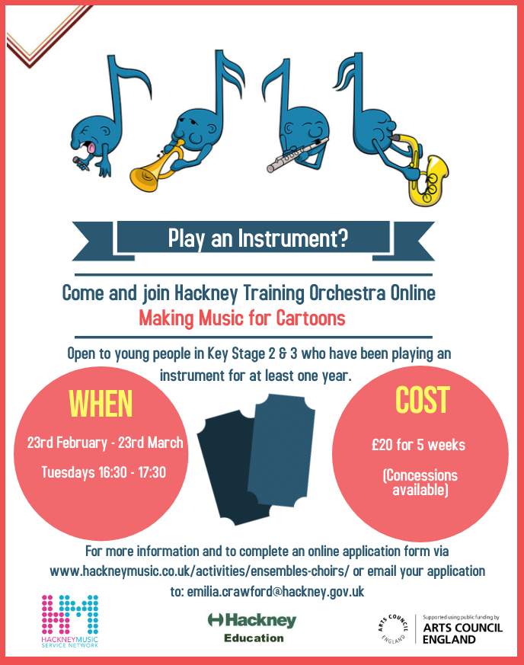

Hackney Training Orchestra: Making Music for Cartoons Online

Thank you for your interest in our Making Music for Cartoons sessions.
Please complete the details below (1 form per applicant).

The course is open to anyone young person in Key stage 2 and 3 who has been playing an instrument for at least one year. The cost for 5 weeks £20 (concessions available). The sessions will take place via Zoom between Tuesday 23rd February - Tuesday 23rd March 2021 - each session will take place 16:30 - 17:30

Once you have submitted this form or for more information please email: emilia.crawford@hackney.gov.uk

Please use block capitals

Applicant’s Name:________________________________________________________

Male Female Other Prefer not to say

Parent’s name (Mr/Mrs/Ms): ____________________________________________________________________

Telephone No.:__________________________________ Emergency contact No: _________________________

Email: ______________________________________________________________________________________

Home Address: _______________________________________________________ Post code:______________

School :______________________________________________ Borough: ______________________________

Year Group:___________________________________________________ Date of birth:____________________

Signature of Parent / Carer: ____________________________________________ Date: _________________
Does the applicant receive Free School Meals? Yes No

Does the applicant have any special educational needs? If so please inform us below Yes No
Some questions about your instrument.
Instrument: ____________________________________________________ Standard (Grades taken if any):____________________

Any other Information:_________________________________________________________________________

How did you hear about this opportunity? _________________________________________________________

Please help us monitor and improve our provision by completing the following:

1. White 2. Mixed 3. Asian or British Asian 4. Black or British Black 5. Chinese

6. Any other Ethnic Group 7. Refused

